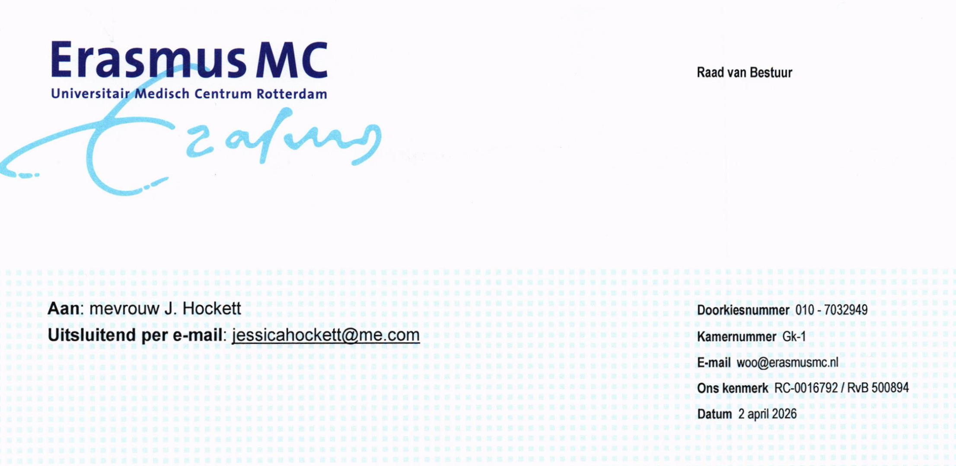
Dear Ms. Hockett,
Introduction
On February 25, 2026, you submitted a request to Erasmus University via email pursuant to Article 4.1, paragraph 1 of the Government Information (Public Access) Act (hereinafter: the “Woo”). On March 3, 2026, Erasmus University forwarded your Woo request to the Executive Board of Erasmus MC (hereinafter: the “Executive Board”). Your Woo request concerns “correspondence between two employees during the period from November 1, 2019, up to and including December 31, 2019.” Receipt of your Woo request was confirmed by Erasmus MC on March 11, 2026.
Initial Decision
The Executive Board rejects your request for the disclosure of information pursuant to the Woo. This decision is based on the grounds set out below:
Executive Board
Prof. Dr. S. Sleijfer
Chair and Dean
Dr. Ir. P.A.M. Boomkamp
Vice-Chair and CFO
Ir. D.M. Schraven
Member of the Executive Board
Prof. Dr. P.A.E. Sillevis Smit
Acting Member of the Executive Board
Board Secretary
Ms. A.F. Peelen
- The Woo is not applicable due to a failure to meet the definition of “document,” as defined in the Woo;
- The ground for refusal: the proper functioning of the State, other public-law bodies, or administrative bodies—pursuant to Article 5.1, paragraph 2, preamble and under (i) of the Woo—precludes the disclosure of the requested information;
- The ground for refusal: respect for personal privacy—pursuant to Article 5.1, paragraph 2, preamble and under (e) of the Woo—precludes the disclosure of the requested information.
The aforementioned grounds are set out in further detail below:
Ad 1: The concept of “document” within the meaning of the Woo
The Woo applies to documents as defined in Article 2.1 of the Woo:
“a written piece or other body of recorded data drawn up or received by an organ, person, or board as referred to in Article 2.2, paragraph 1, which by its nature relates to the public task of that organ, that person, or that board”
Article 2.2 of the Woo stipulates that it applies to administrative bodies. Erasmus MC—or at least its Executive Board—qualifies as an administrative body pursuant to Article 12.3 of the Higher Education and Scientific Research Act (WHW). The Woo is therefore applicable only to information relating to the exercise of that public authority, or to matters that are prerequisite conditions for the exercise of that public authority. This also follows from Article 2.1 of the Woo, which indicates that the document must relate to the “public task” of that organ.
The information you seek to obtain is, by its nature, not “public” and, moreover—for reasons to be discussed in further detail below—may not be disclosed at all pursuant to the Woo. The fact that the individuals named in your Woo request are employed by Erasmus MC is not sufficient to bring the matter within the scope of the Woo.
The public task of Erasmus MC pertains to the following subjects. Pursuant to the WHW, Erasmus MC—as an academic hospital—is responsible for providing education to students that is funded by the State, and Erasmus MC ...research funded by public money (see also Article 1.4 of the Awb [General Administrative Law Act]). To fall within the scope of the Woo [Open Government Act], a necessary prerequisite is that the matter in question falls under the public duty of the academic hospital (Article 2.1 Woo), or concerns matters that are ancillary to the exercise of that public duty. The requested information does not fall under this category.
Since the requested information bears no relation to the public duty of Erasmus MC, the documents in question cannot be deemed to relate to the exercise of public authority. The documents therefore fall outside the scope of the Woo.
Ad 2: Proper functioning of the State
Even if the Woo were applicable—and even if the documents in question were deemed to constitute “documents” within the meaning of the Woo—the requested information cannot be disclosed.
Article 5.1, paragraph 2, introductory clause and under (i) of the Woo provides that disclosure of information may be withheld insofar as the interest in disclosure does not outweigh the interest in the proper functioning of the State, other public-law bodies, or administrative bodies.
Specifically, in the present case, disclosure of the requested documents could jeopardize effective cooperation and the participation of natural persons in advisory bodies. Medical professionals might then no longer be willing to participate in necessary government advisory bodies, such as, for example, the National Institute for Public Health and the Environment (RIVM).
In the event of disclosure, the persons involved would feel less at liberty to participate in discussions and to exchange views freely. This could affect the proper functioning of staff members. The matters discussed must remain confidential. Only in this way can it be ensured that individuals are able to exchange views freely. This was also held by the District Court of North Holland in its judgment of June 30, 2025.
Ad 3: Infringement of personal privacy
In addition to the aforementioned ground for refusal, the requested information cannot be made public pursuant to Article 5.1, paragraph 2, introductory clause and under (e) of the Woo.
The personal data of the involved natural persons have been redacted. Without disproportionate effort on the part of third parties, whether internal or external, this information can be traced, directly or indirectly, back to the identities of the persons involved. Given the wording of your Woo request, the content of the email correspondence must also be redacted pursuant to Article 5.1, paragraph 2, introductory clause and under (e) of the Woo. The content of the requested email correspondence will, at all times, be traceable to the individuals named in your Woo request.
Comprehensive Refusal
Given that the Woo does not apply to the information gathered in response to your request, collective exclusion is permissible. However, even if the Woo were to apply, the Executive Board has conducted a balancing of interests at the document level. Nevertheless, for all documents, the justification for not disclosing them is the same.
It follows from the previously cited ruling by the District Court of North Holland that, when the justification for not disclosing the documents is the same for all documents, reliance may consistently be placed, for all parts of the documents, on Article 5.1, paragraph 2, introductory clause and under (i), of the Woo.
For the sake of completeness, we note that the individuals to whom your Woo request pertains continue to face serious threats to this very day; on this basis, there exists a compelling interest in not disclosing the requested documents.
We trust that we have hereby provided you with sufficient information.
Sincerely,
On behalf of the Board of Directors of Erasmus MC
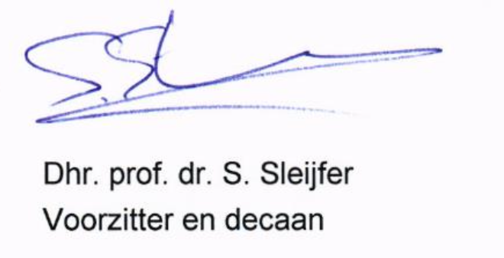

Rechtbank Noord-Holland 30 juni 2025, ECLI:NLrRBNHOr2025:6994, r.o. 5.1 en 8.'1-8.7
?Rechtbank Noord-Holland, 30 juni 2025, ECLI:NL:RBNHO:2025:6994, r.o 8.2.

